LABORATORY # 08

Amplification of a Signal at Low/High Frequencies Using BJTs

We have already discussed introduction in Lab # 7. Let starts with circuit.
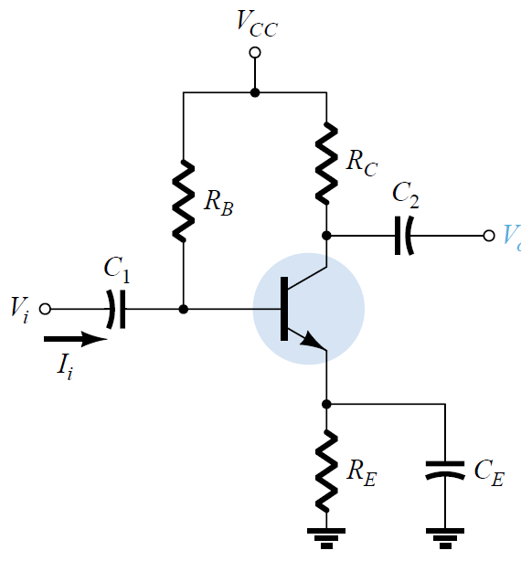
Figure 8.1 Common Collector Circuit
- Analyze the effect of Capacitor (C1, C2 and Ce) using 3.3uF, 1.0uF and 470uF. For each value of capacitor, apply the input signal with V=100mVpp at given range of frequencies (see Table 8.1) to the given circuit as shown in Fig. 8.1. Evaluate the behavior of an input signal with npn type BJT (2N3903/MPSA42). Use R_{B} = 15KΩ, R_{C}=1KΩ, R_{E}=1.5KΩ and V_{CC}=16V.
- Repeat part 1 for Vin=1Vpp
Procedure:
- Build the circuit as shown in Figure 8.1 in Multisim and amplify the input signal at given frequencies (Low/High) using BJT (2N3903/MPSA42).
- Build the circuit as shown in Figure 8.1 in Lab and amplify the input signal at given frequencies (Low/High) using BJT (2N3903/MPSA42).
- Complete Table 8.1 with your Multisim and experimental results.
- Attach input and output waveforms for both Multisim and experimental results.
- Discuss results in conclusion section. Analyze in terms of low/high value of capacitors
- Compare and discuss your results at Vin=100mV with Vin=1.0V.
- Compare amplification of a signal using BJT with respect to Op-Amp 741 (Lab 2).
- Draw the bandwidth graph based on your lab results for Vin=100mV and 1V.
Table 8.1
Simulation, Vpp=0.1V
Frequency | Vout (V) | Voltage Gain
10 | 0.000
30 | 0.019
60 | 0.026
100 | 0.030
200 | 0.033
500 | 0.203
1 KHz | 0.773
2 kHz | 1.915
5 KHz | 3.641
10 KHz | 3.956
15 KHz | 4.004
20 KHz | 4.030
50 KHz | 4.053
75 KHz | 4.058
100 KHz | 4.065
150 KHz | 4.077
200 KHz | 4.083
500 KHz | 4.160
750 KHz | 4.132
1 MHz | 4.113
1.5 MHz | 3.792
2.0 MHz | 2.646

Hardware, 1Vpp

Frequency | Vout | Voltage Gain
10 | 0.000
30 | 0.164
60 | 0.458
100 | 0.879
200 | 2.046
500 | 3.982
1 KHz | 4.360
2 kHz | 4.231
5 KHz | 4.229
10 KHz | 6.029
15 KHz | 5.599
20 KHz | 5.890
50 KHz | 6.042
75 KHz | 7.252
100 KHz | 6.040
150 KHz | 5.734
200 KHz | 5.452
500 KHz | 5.281
750 KHz | 4.849
1 MHz | 4.853
1.5 MHz | 4.937
2.0 MHz | 5.091

Two exemplary circuits are shown below for reference purpose only.

